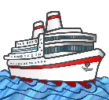
My Antarctica Ship LC
Draw and label a picture of your ship.

