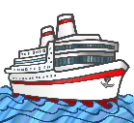
My Antarctica Ship LC

My ship is called ____________________________________.

My ship is built from ________________________________.

It has a crew of ________________________ people.

