Wednesday 13th January WALT: Know and understand compound words HC
So P3 hopefully you have watched the Powerpoint and now know and understand that a compound word is made up of two words put together to form a new word with a different meaning.
fire 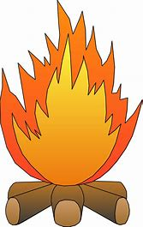 + man  = fireman 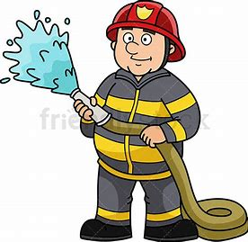
Let’s see if you can complete the compound word challenge below! You can do this P3 

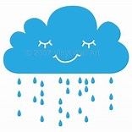 +  =

___ ___ ___ ___ ___ ___ ___ __ __ __ __ __ __ __

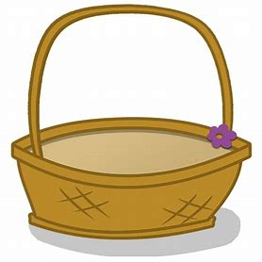 + 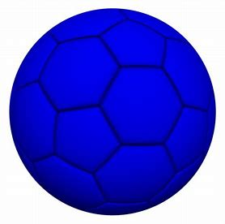 =

__ __ __ __ __ __ ___ ___ ___ __ __ __ __ __ __ __ __ __ __ __
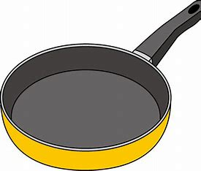 + 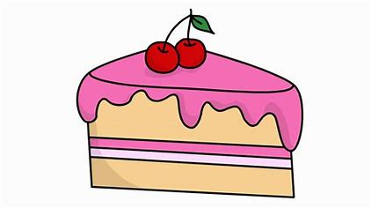 =

__ __ __ __ __ __ __ __ __ __ __ __ __ __
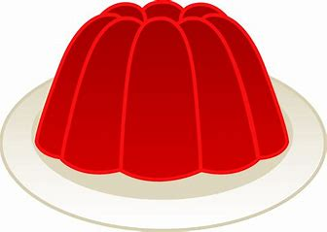 + 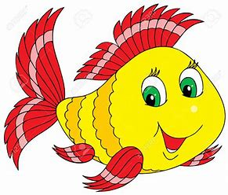 =

__ __ __ __ __ __ __ __ __ __ __ __ __ __ __ __ __ __

Now that you have completed your challenge, are you ready for another? This time you are going to make two new words out of the compound words below. Are you ready, steady, go!

= +

raincoat __ __ __ __ __ __ __ __

= +

toothbrush __ __ __ __ __ __ __ __ __ __

= +

hotdog __ __ __ __ __ __

Choose your favourite 3 compound words and write 3 super duper sentences.

- ________________________________________________________________________________________________________________________________

- ________________________________________________________________________________________________________________________________

- ________________________________________________________________________________________________________________________________

