Wednesday 13th January WALT: Know and understand compound words MC
So P3 hopefully you have watched the Powerpoint and now know and understand that a compound word is made up of two words put together to form a new word with a different meaning.
fire 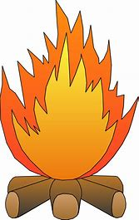 + man  = fireman 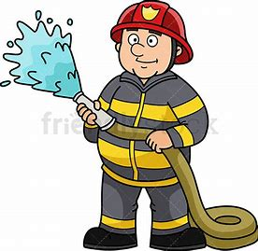
Let’s see if you can complete the compound word challenge below! You can do this P3 

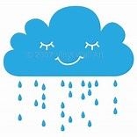 + 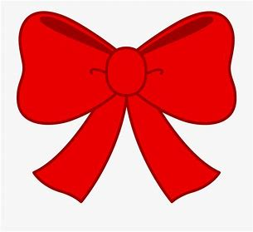 =

rain bow __ __ __ __ __ __ __

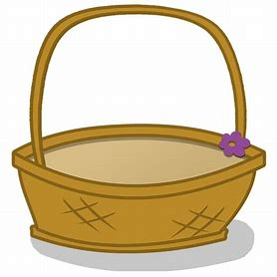 + 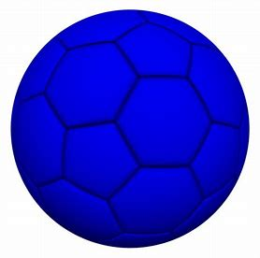 =

basket ball __ __ __ __ __ __ __ __ __ __
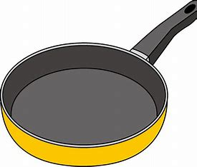 + 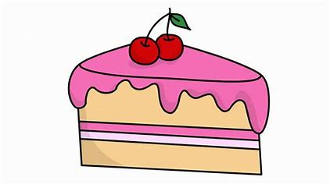 =

pan cake __ __ __ __ __ __ __
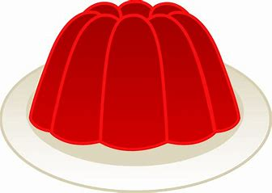 + 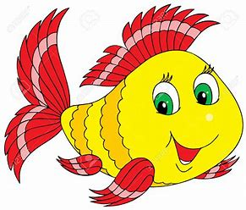 =

jelly fish __ __ __ __ __ __ __ __ __

Now that you have completed your challenge, are you ready for another? This time you are going to make two new words out of the compound words below. Are you ready, steady, go!
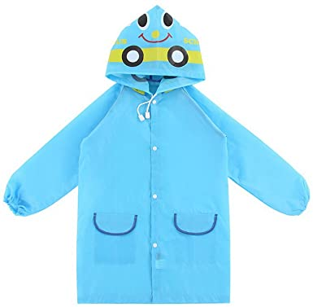

= +

raincoat __ __ __ __ __ __ __ __
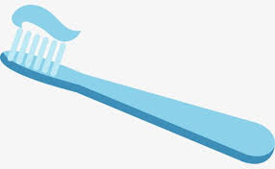

= +

toothbrush __ __ __ __ __ __ __ __ __ __

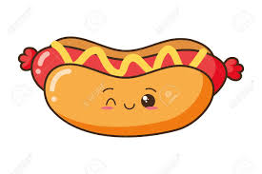

= +

hotdog __ __ __ __ __ __

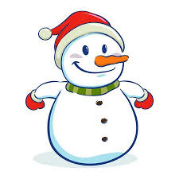

= +

snowman __ __ __ __ __ __ __

Choose your favourite compound word and write 1 super duper sentence.
- ________________________________________________________________________________________________________________________________

