Wednesday 13th January WALT: Know and understand compound words. LC
Hi P3, today we are going to look at compound words again. Remember a compound word is made up of two words put together to form a new word. Take a look at yesterday’s Powerpoint again to refresh your memory.
fire 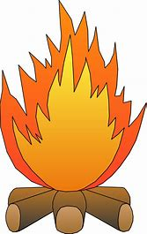 + man  = fireman 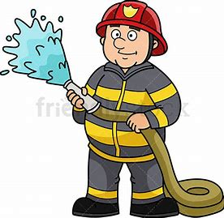
Let’s see if you can try some yourself. I know you can do it
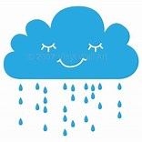 + 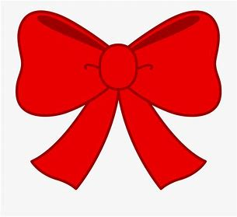 =

rain bow __ __ __ __ __ __ __
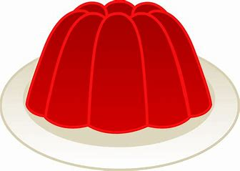 + 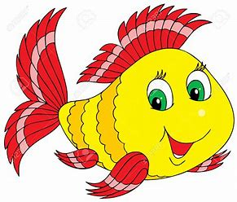 =

jelly fish __ __ __ __ __ __ __ __ __
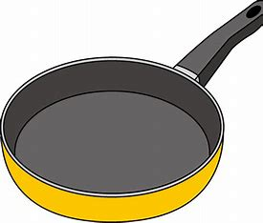 + 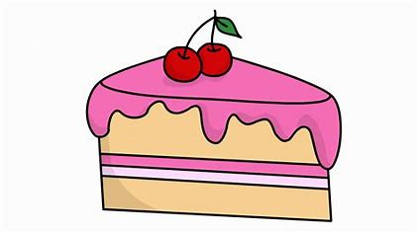 =

pan cake __ __ __ __ __ __ __

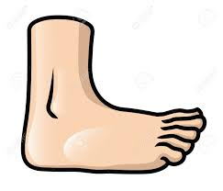 + 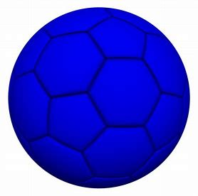 =

foot ball __ __ __ __ __ __ __ __

