The Pet Bugs

Ivan has got four pet bugs that he keeps on his bookshelf. One is a ladybird, one is a spider, one is a beetle and the other is an ant. He likes to change the order in which they sit on the shelf. How many different ways can he do this? Do you want to cut out the pictures below or do you want to make a list?

I have started:
Order the Bugs List

Ladybird, Spider, Beetle, Ant

Ivan’s Insects

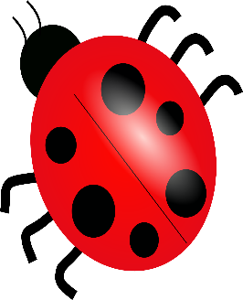  Ladybird | Spider | Beetle | Ant

Going Further

What if Ivan had a shoe, a book, an apple, a teddy, and a pencil on his bookshelf. How many ways could he arrange them?

