Wednesday 3rd March
WALT – give change from 50p
Brookies Homewares Shop
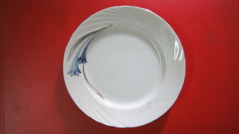
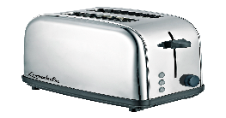
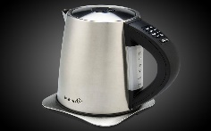

kettle - 35p toaster -27p plate- 19p

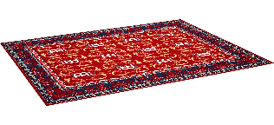


hoover – 39p cushion – 18p rug – 23p

Buy with 50p | price | sum to work out the change | coins for the change
hoover | 39p | 50p – 39p =
kettle
toaster
rug and plate
cushion

