Wednesday 3rd March
WALT – give change from 20p
Brookies Homewares Shop
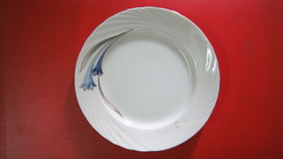
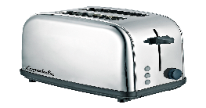
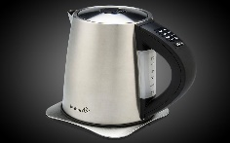

kettle - 11p toaster -17p plate- 5p

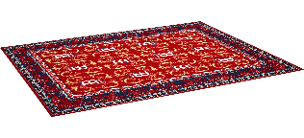


hoover – 16p cushion – 9p rug – 7p

Buy with 20p | price | sum to work out the change | coins for the change
hoover | 16p | 20p – 16p =
kettle
toaster
rug and plate
cushion

