How much money?

Sam has two of these coins in her pocket.

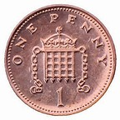
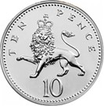
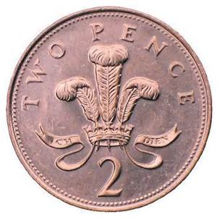
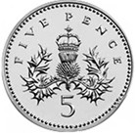

How much money could Sam have?

Find all the amounts possible. Can you make a list?

Going Further

Sam has a 2p, 5p, 10p and 20p. She gives two coins to her brother. Make a list of how much she can give her brother.

