29.1.21 Regular Plurals HC
WALT: make singular words plural by adding s.
We add s to make some words plural. For example,
Cat 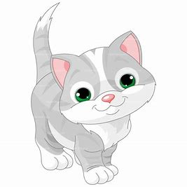 Cats
Sock  Socks 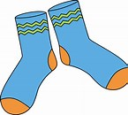
Lollipop Lollipops
Can you make the singular words plural? The first one has been done for you .
Singluar | Plural
frog 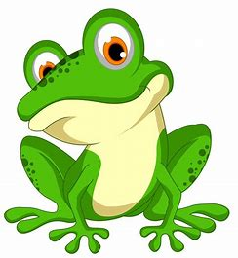 | 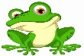  frogs
tree
pineapple
earring
book
rainbow
jumper
bicycle
snake
kitten
Part 2
Read the sentences below. The words in the box need to be made plural before they will fit into each sentence. Can you make the words plural by adding s?

pencil sweet bed cat coin shoe toys sock dog

I ate four sweets before I had my tea.

Dad told Max and Molly to make their __________ before breakfast.

We put our ___________ and ________ on to go outside to play.

___________ and ____________ are very popular pets.

Put all your ____________ into your pencil case before break.

I am saving up lots of ____________ in my money box.

Granny buys me ___________ when we go shopping in Belfast.

