29.1.21 Regular Plurals MC
WALT: make singular words plural by adding s.
We add s to make some words plural. For example,
Cat 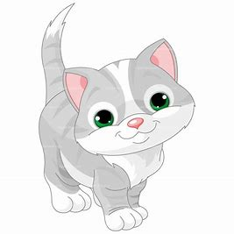 Cats
Sock  Socks 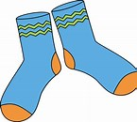
Lollipop Lollipops
Can you make the singular words plural? The first one has been done for you .
Singluar | Plural
frog 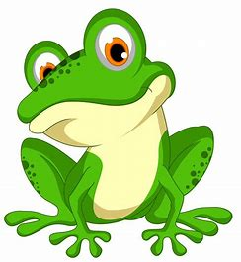 |   frogs
tree
pencil
cupcake
book
rainbow
shirt
chip
bag
Ipad
Part 2
Read the sentences below. The words in the box need to be made plural before they will fit into each sentence. Can you make the words plural by adding s?

pencil sweet bed cat coin shoe sock dog

I ate four sweets before tea.

Dad told us to make our __________ before breakfast.

We put our ___________ and ________ on to go outside.

___________ and ____________ are popular pets.

Put all your ____________ into your pencil case.

I have lots of ____________ in my money box.

