29.1.21 Regular Plurals LC
WALT: make singular words plural by adding s.
We add s to make some words plural. For example,
Cat 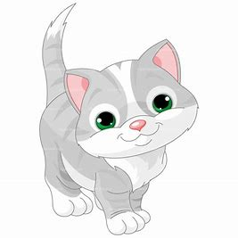 Cats
Sock  Socks 
Lollipop Lollipops
Can you make the singular words plural? The first one has been done for you .
Singluar | Plural
frog 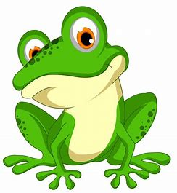 | 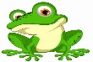  frogs
tree
bun
ear
chip
sweet
hen
bell
pin
cat

