Hello P3 Explorers! Today you are going to imagine that you are a member of the Nimrod Expedition from 1907. Remember there were no iPads or mobile phones in 1907!!
Write some sentences in your diary about how it felt to travel across the ice.
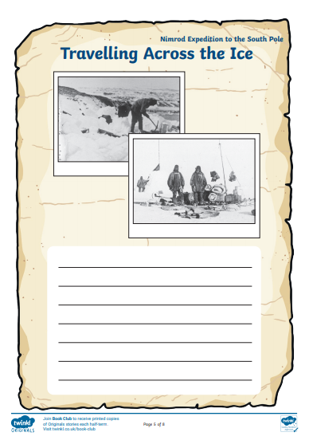
What was the weather like? What did you wear? Where did you sleep? How long did it take you? What tools did you use to help? How did you feel when you got to 97miles from the South Pole and had to stop?

