Hello P3 Explorers! Today you are going to imagine that you are a member of the Nimrod Expedition from 1907. Remember there were no iPads or mobile phones in 1907!!
Write some sentences in your diary about how it felt to be going on such a big adventure!
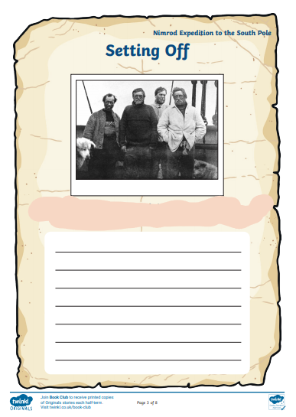
What did you pack? How did you travel – bus, car, or boat? How did you feel?

