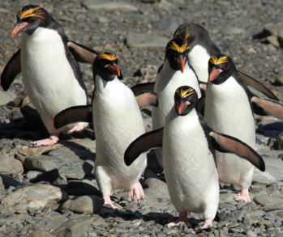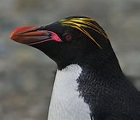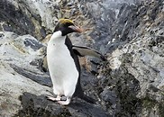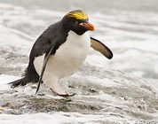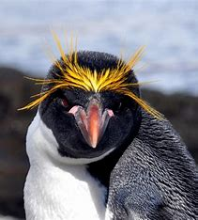
Macaroni Penguins
There are over 18 million macaroni penguins in the world. Macaroni penguins can only be found in the continent of Antarctica and really like rocky areas. The big groups that macaroni penguins live in are called colonies. Macaroni penguins are crested birds and have yellow feathers on their heads called airgettes. These aigrettes look like macaroni pasta. Some macaroni penguins build nests using pebbles, mud and sand, but others lay their eggs on bare rock. In the winter, macaroni penguins are found mostly in water. In the summer they have to come on land to lay their eggs and care for their babies. Macaroni penguins eat fish, squid and krill and spend half the year in the ocean hunting for food to eat.
Remember to answer in full sentences with capital letters and full stops
- How many macaroni penguins are there in the world?
_______________________________________________________________
- Where can macaroni penguins be found?
_______________________________________________________________

- What do you call the big groups that macaroni penguins live in?
_______________________________________________________________

- What do macaroni penguins have on their heads?
_______________________________________________________________

- What do the aigrettes look like?
_______________________________________________________________

- What do some macaroni penguins use to build their nests?
_______________________________________________________________

- What do macaroni penguins eat?
______________________________________________________________

- Where do macaroni penguins spend half the year?
______________________________________________________________

