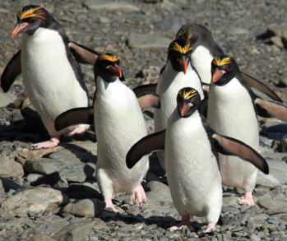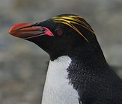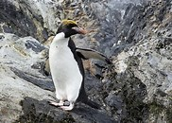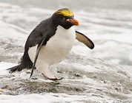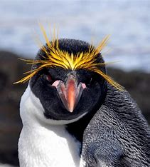
Macaroni Penguins
There are over 18 million macaroni penguins in the world. Macaroni penguins can only be found in Antarctica. They really like rocky areas. Macaroni penguins live in big groups called colonies. Macaroni penguins have yellow feathers on their heads called airgettes. Aigrettes look like macaroni pasta. Macaroni penguins eat fish, squid and krill. They spend half the year in the ocean hunting for food.
Remember to answer in full sentences with capital letters and full stops
- How many macaroni penguins are there in the world?
______________________________________________________
______________________________________________________

- Where can macaroni penguins be found?
____________________________________________________________________________________________________________

- What are the big groups they live in called?
____________________________________________________________________________________________________________

- What do aigrettes look like?
____________________________________________________________________________________________________________

- Where do macaroni penguins spend half the year?
____________________________________________________________________________________________________________

