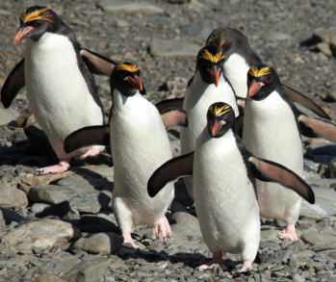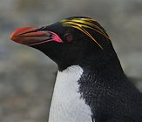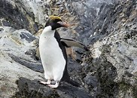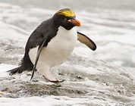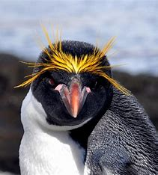
Macaroni Penguins
There are over 18 million macaroni penguins in the world.
1.There are o_ _ _ 18 million macaroni penguins in the w _ _ _ _.

Macaroni penguins only live in Antarctica.
2. Macaroni penguins only live in A_ _ _ _ _ _ _ _ _.

They really like rocky areas.
3. T_ _ _ really like r_ _ _ _ areas.

Macaroni penguins live in big groups called colonies.
4. Macaroni penguins live in b_ _ groups c_ _ _ _ _ colonies.

They have yellow feathers on their heads.
5.They have y_ _ _ _ _ feathers on their h _ _ _ _.

Macaroni penguins eat fish, squid and krill.
6. Macaroni penguins e_ _ fish, s_ _ _ _ and krill.

Can you draw a macaroni penguin?

