Object Detectives HC/MC
Look at the photos below, all these objects would have been found in a Victorian House. Can you name them?
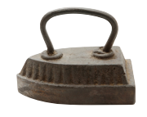  1 | i____________
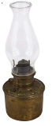  2 | g_______ l________
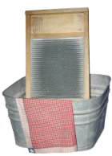  3 | w____________
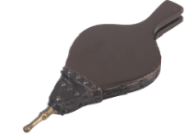  4 | b____________
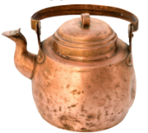  5 | c_______k__________
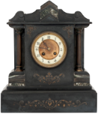  6 | m_______ c__________
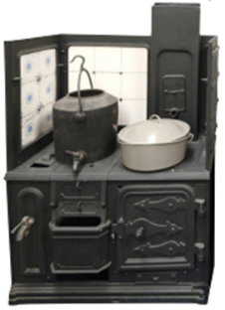  7 | r____________
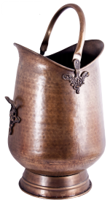  8 | c_______ s_____________
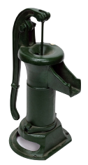  9 | w________ p___________
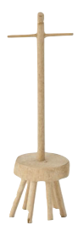  100 | d____________

