Object Detectives LC
Look at the photos below, all these objects would have been found in a Victorian House. Can you name them?
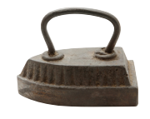  1 | i _ _ _
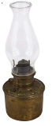  2 | g _ _ l _ _ _
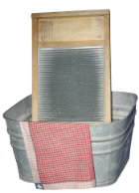  3 | w _ _ _ _ _ _ _ _
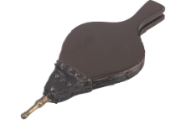  4 | b _ _ _ _ _ _
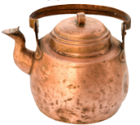  5 | c _ _ _ _ _ k _ _ _ _ _
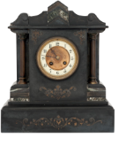  6 | m _ _ _ _ _ c _ _ _ _
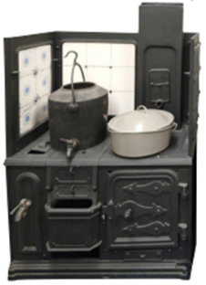  7 | r _ _ _ _
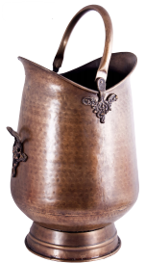  8 | c _ _ _ s _ _ _ _ _ _
iron gas lamp bellows

washboard mantle clock copper kettle

range coal scuttle

