Photo of house | Name of house
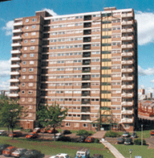 | f _ _ _ _
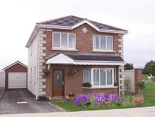 | d_ _ _ _ _ _ _
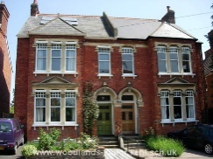 | s_ _ _ - d_ _ _ _ _ _ _
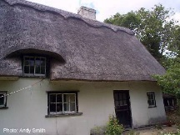 | c _ _ _ _ _ _
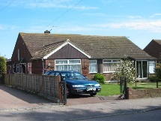 | b _ _ _ _ _ _ _
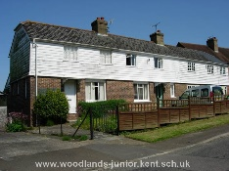 | t _ _ _ _ _ _ _
semi-detached terraced bungalows
cottages detached flats

