We are learning about Antarctica.
All About Antarctica
Think about all the information you have learnt about Antarctica.
Use this information to complete the activity below.

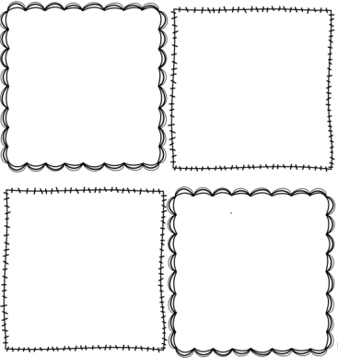
Draw and label 4 pictures which illustrate facts about Antarctica. The first one has been completed for you.
Emperor Penguins


