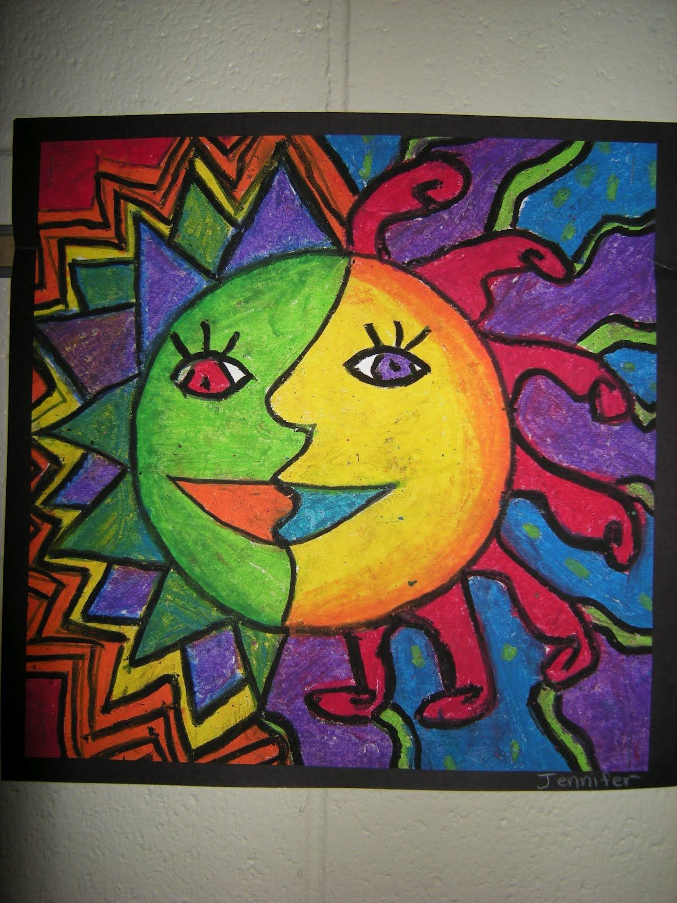
Create an Aztec Sun

This week marks the Summer Solstice, the longest day in the Northern Hemisphere.
Design your own sun, using bright and bold colours to mark this occasion.
Send us some pictures of your creations to brighten our website!

