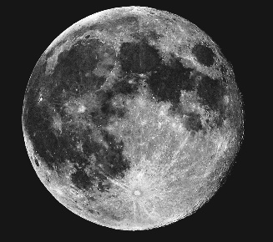
Asking Questions

WALT - Use question words.
Choose the correct question word to finish each question for
Neil Armstrong.

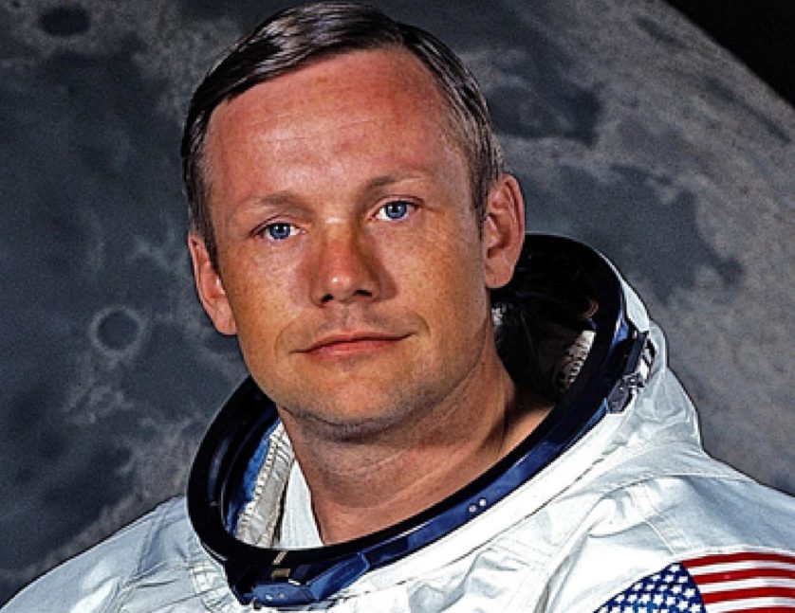
1. ___________ is your name?

2. ___________ did you go to the moon?

3. ___________ did you go to school?

4. ___________ went with you?

5. ___________ did you want to be an astronaut?

Who What Where

When Why

Think of 2 more questions to ask Neil Armstrong.

