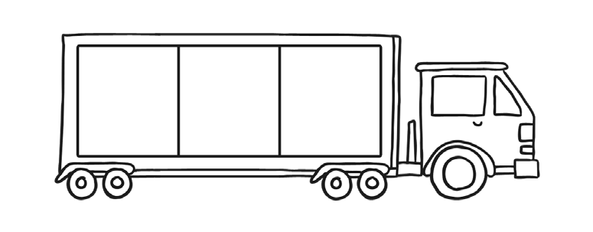

16 17
17 18
11 12
14 15
18 19
12 13
15 16
One More Number Writing Sheet

8
9
10
visit twinkl.com

