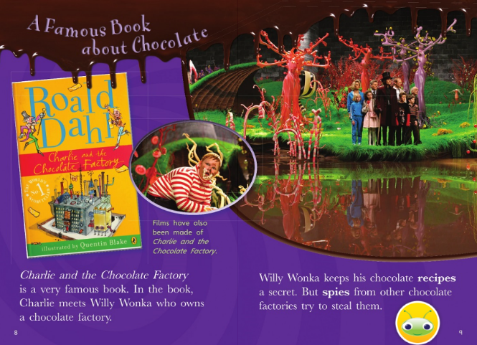

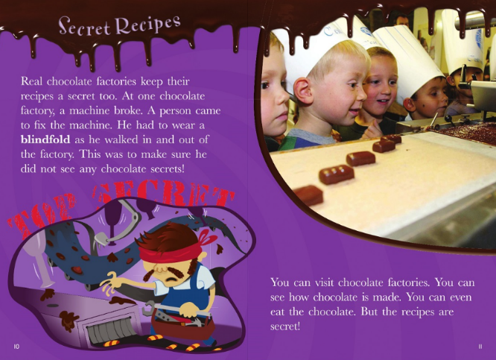

1. Who wrote Charlie and the Chocolate Factory?
______________________________________________________________
2. Who does Charlie meet?
______________________________________________________________
3. What does he own?
______________________________________________________________
4. What do chocolate factories keep secret?
______________________________________________________________
5. What happened to the person who had to fix the machine?
______________________________________________________________
6. Would you be able to keep the recipe a secret? Yes/No Give a reason.
______________________________________________________________

Draw a picture of your favourite chocolate bar!

