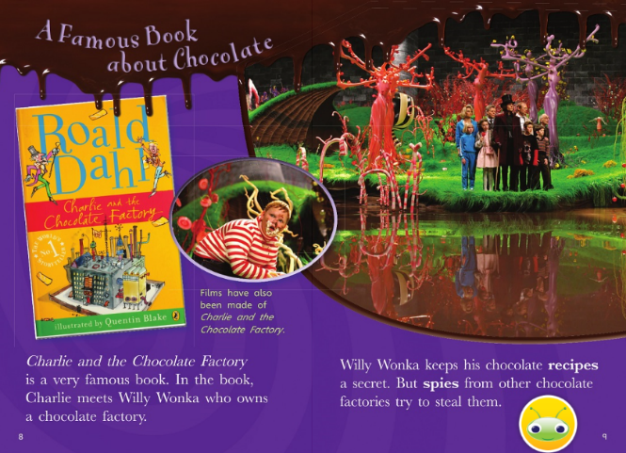

- Who wrote Charlie and the Chocolate factory?
________________________________________________________________
- Who owns the chocolate factory?
________________________________________________________________
- What did he need to keep secret?
________________________________________________________________
- Would you be able to keep the secret? Yes/No Give a reason.
________________________________________________________________
Draw a picture of your favourite chocolate bar!

