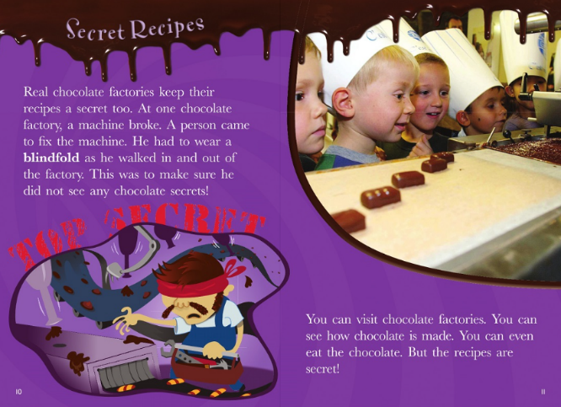

Can you look back to find the missing words?
You can visit c_______ factories.
You can see how chocolate is m_____.
You can even e_____ the chocolate.
The recipes are s________!

Now draw your favourite chocolate bar!

