to two

1. Neil Armstrong went _____ the moon.
2. There were _____ men on the moon.
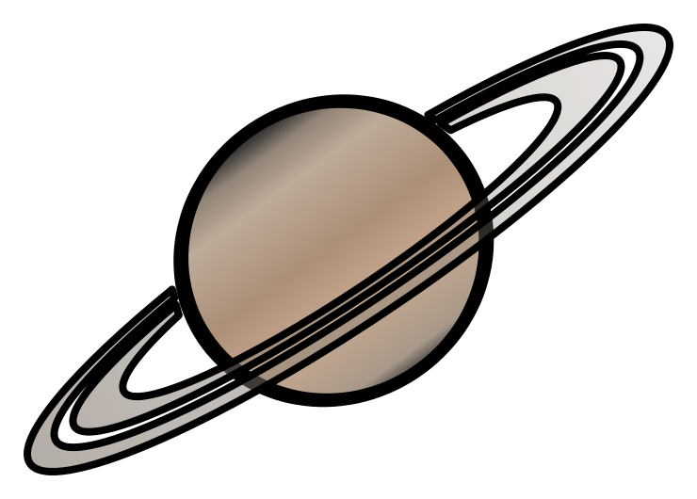
3. I can see ____ planets.

there their

1. The astronauts wear ______ suits.
2. ________ were 12 men who walked on the moon.
3. They went _______ in a rocket.

