Monkey Nuts

Michael ate a lot of monkey nuts at Halloween. He noticed that some shells had 3 nuts and some had 4 nuts.

Altogether Michael had 23 monkey nuts.

- How many shells had 3 nuts and how many shells had 4 nuts?

Going Further

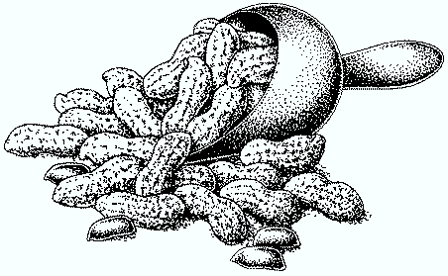
- What if Michael had 25 monkey nuts?

