Phonics: s, a, t, p, i, n
Say what you see. Stretch and write the sounds.

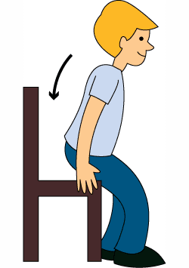
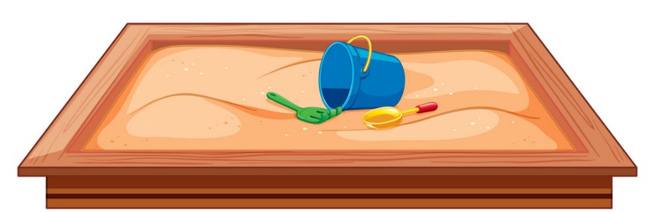

___ ___ ___
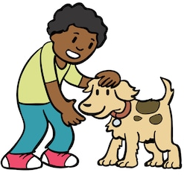
___ ___ ___
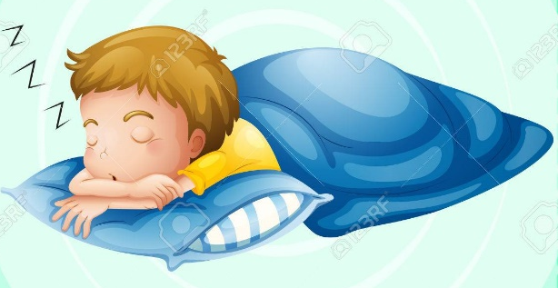

___ ___ ___
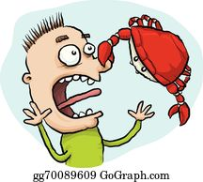
___ ___ ___


___ ___ ___ ___ ___ ___

Phonics: s, a, t, p, i, n, m, o, c
Say what you see. Stretch and write the sounds.
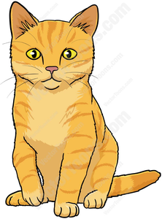
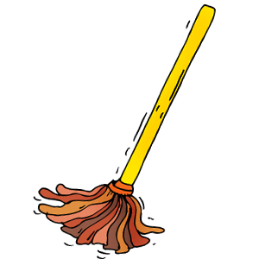

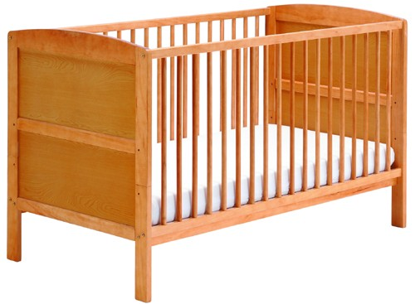

___ ___ ___ ___ ___ ___ ___ ___ ___

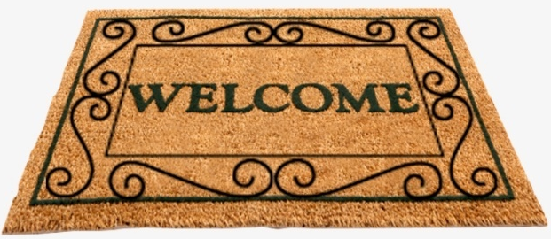


___ ___ ___
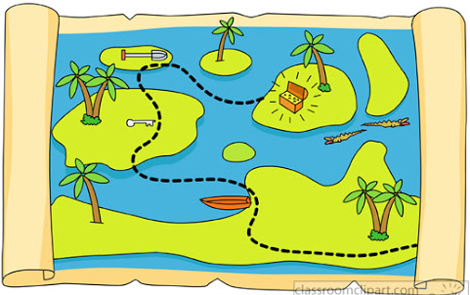
___ ___ ___
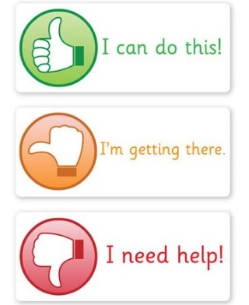
Self-assessment: Please tick.

___ ___ ___
Phonics: s, a, t, p, i, n, m, o, c, f, r, d
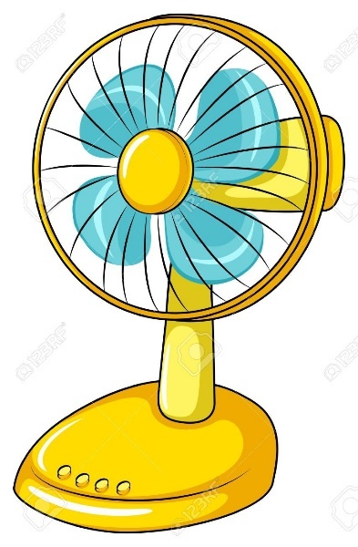
Say what you see. Stretch and write the sounds.

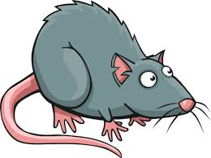

___ ___ ___ ___ ___ ___ ___ ___ ___
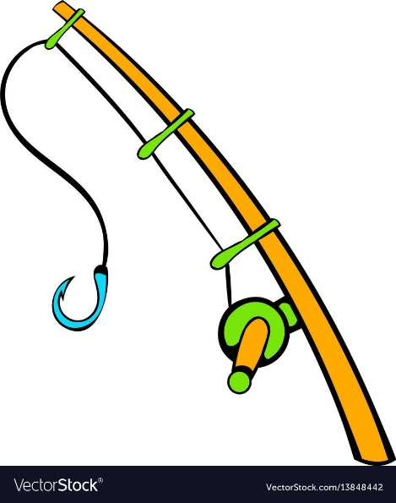



___ ___ ___ ___ ___ ___ ___ ___ ___

Phonics: s, a, t, p, i, n, m, o, c, f, r, d, h, u, b
Say what you see. Stretch and write the sounds.


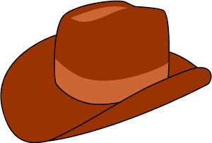

___ ___ ___ ___ ___ ___ ___ ___ ___

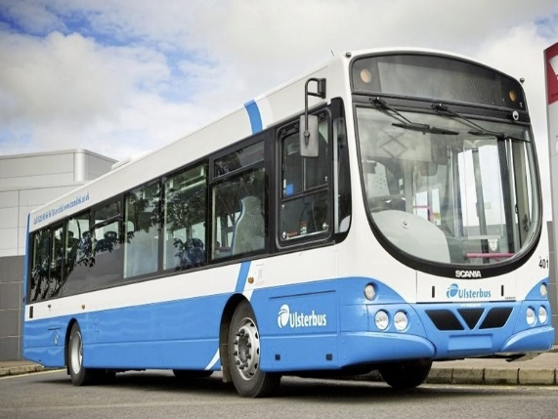
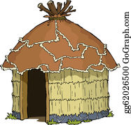

___ ___ ___ ___ ___ ___ ___ ___ ___

Phonics: s, a, t, p, i, n, m, o, c, f, r, d, h, u, b, g, e, l
Say what you see. Stretch and write the sounds.
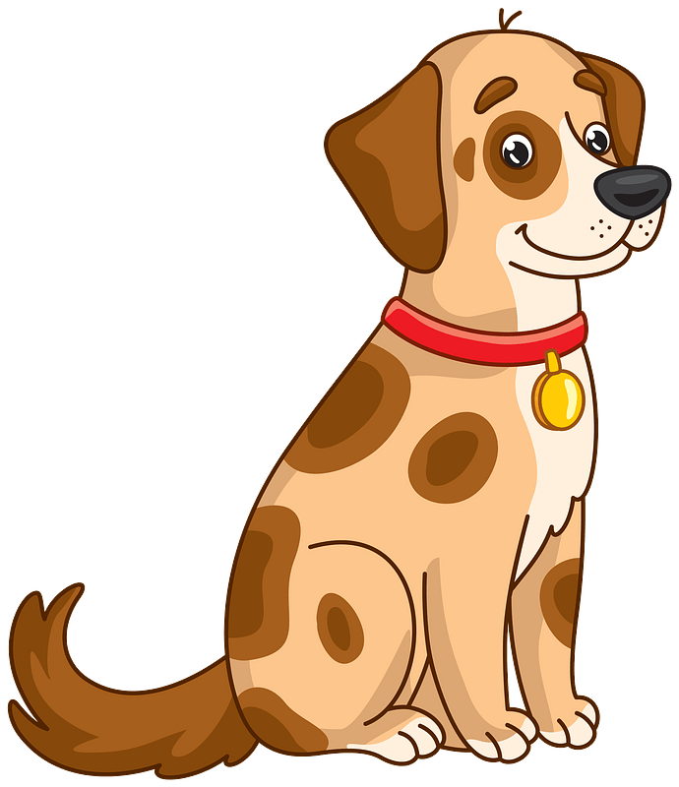
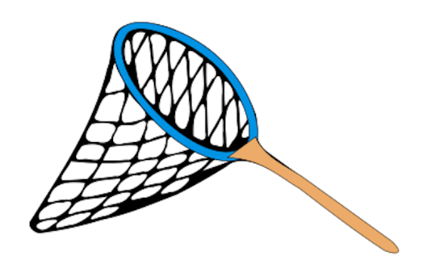


___ ___ ___ ___ ___ ___ ___ ___ ___
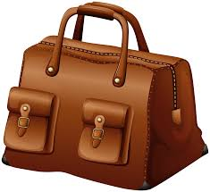

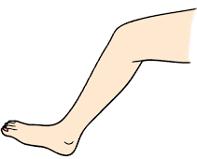

___ ___ ___ ___ ___ ___ ___ ___ ___
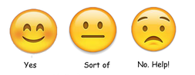
Self-assessment:
Please tick one.
Phonics: s, a, t, p, i, n, m, o, c, f, r, d, h, u, b, g, e, l, w, j, k
Say what you see. Stretch and write the sounds.

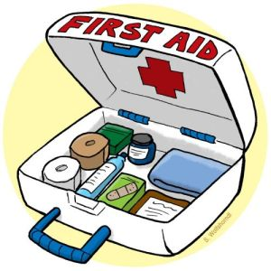
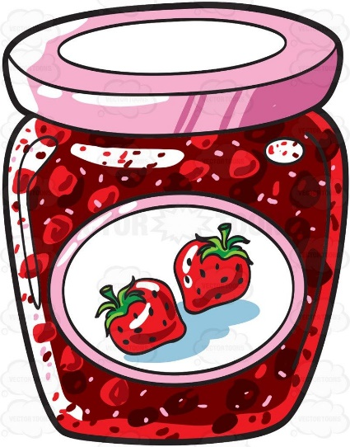

___ ___ ___ ___ ___ ___ ___ ___ ___
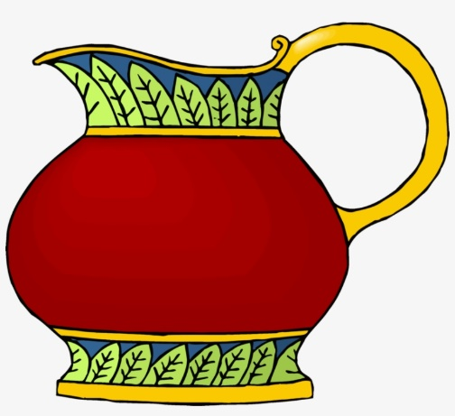

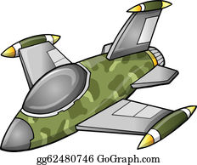

___ ___ ___ ___ ___ ___ ___ ___ ___

Phonics: s, a, t, p, i, n, m, o, c, f, r, d, h, u, b, g, e, l, w, j, k, v, x, y, z
Say what you see. Stretch and write the sounds.
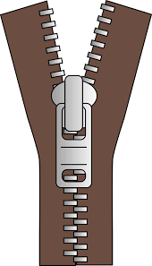
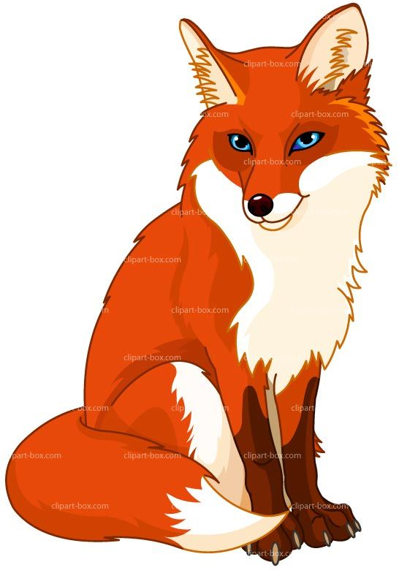
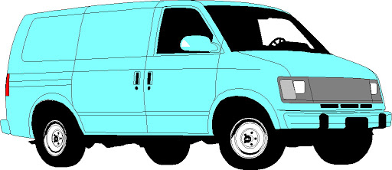

___ ___ ___ ___ ___ ___ ___ ___ ___


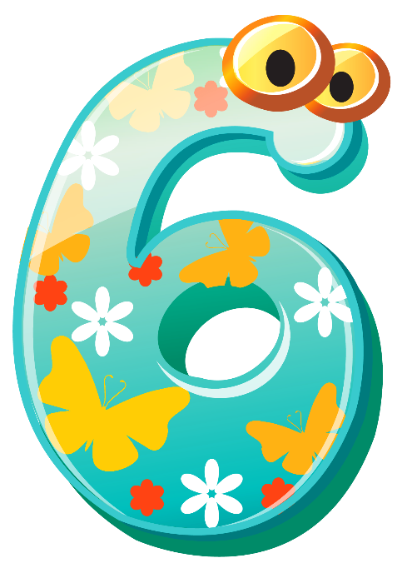

___ ___ ___ ___ ___ ___ ___ ___ ___

Page 1  satpin | Page 2  + moc | Page 3  +frd | Page 4  +hub | Page 5  +gel | Page 6  +wjk | Page 7  +vxyz
sat/sit | mop | fan | hat | dog | jam | van
pit | cat | sad | bun | lip | wet | fox
nap | cot | rat | cut | net | kit | zip
pat | mat | mad | bus | red | jet | six
pan | cap | fun | bin | bag | win | vet
nip | map | rod | hut | leg | jug | box

