Roald Dahl at Repton

This passage is taken from Roald Dahl’s autobiography Boy, in which he describes his early life. When he was thirteen, his mother sent him to Repton Public School for Boys in England. He was very good at sports and enjoyed boxing. However, life at Repton wasn’t all fun, as you are about to discover……!

By now I am sure you will be wondering why I lay so much emphasis on school beatings in this book. The answer is that I cannot help it. All through my school life, I was appalled by the fact that all masters (teachers), including the headmaster, and even the older pupils, were allowed literally to wound other boys, and sometimes quite severely. I couldn’t get over it. I never have got over it.

It would be unfair to suggest that all masters were constantly beating the living daylights out of all the boys in those days. They weren’t. Only a few did. But that was quite enough to leave a lasting impression of horror upon me! It left another more physical impression on me as well! Even today, whenever I have to sit for any length of time on a hard bench or chair, I begin to feel my heart beating along the old lines that the cane made on the palm of my hand some fifty-five years ago!

Do you wonder then that the headmaster’s behaviour used to puzzle me tremendously? He was a church minister at that time, as well as being Headmaster. I would sit in the dim light of the school chapel and listen to him teaching us about God’s mercy and forgiveness, and my young mind would become totally confused. I knew very well that only the day before the headmaster had shown neither mercy nor forgiveness when he was beating some small boy who had broken the school rules.
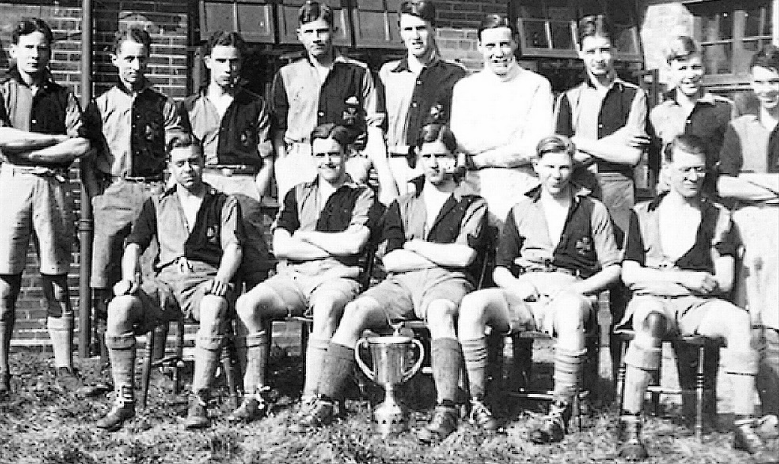

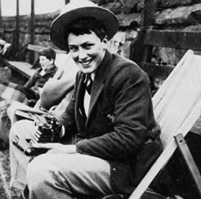
Roald Dahl at Repton School


