The Air Raid
Introduction

This story is set during the Second World War. Britain was at war with Germany and, throughout 1940 and 1941, the German Air Force, known as the Luftwaffe, were bombing London and other major British cities, including Belfast. Night after night, bomber aircraft flew across the English Channel or the North Sea and dropped huge numbers of bombs, causing widespread damage. Along with factories, shipyards and other major targets, many thousands of homes were seriously damaged or destroyed. This was called ‘The Blitz’.
Many families had an air raid shelter in their gardens, and they would rush to the shelter when they heard the air raid siren. This gave them a warning that the Luftwaffe were coming.
In the story, the family have taken refuge in the Anderson Shelter, which has been built in their back garden.
They could sleep in the shelter and a candle provided some light.
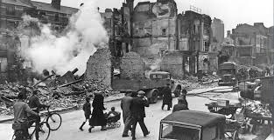
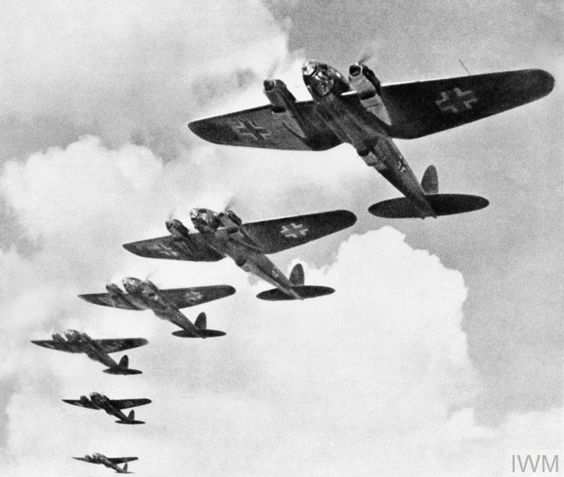
The Luftwaffe The Morning After

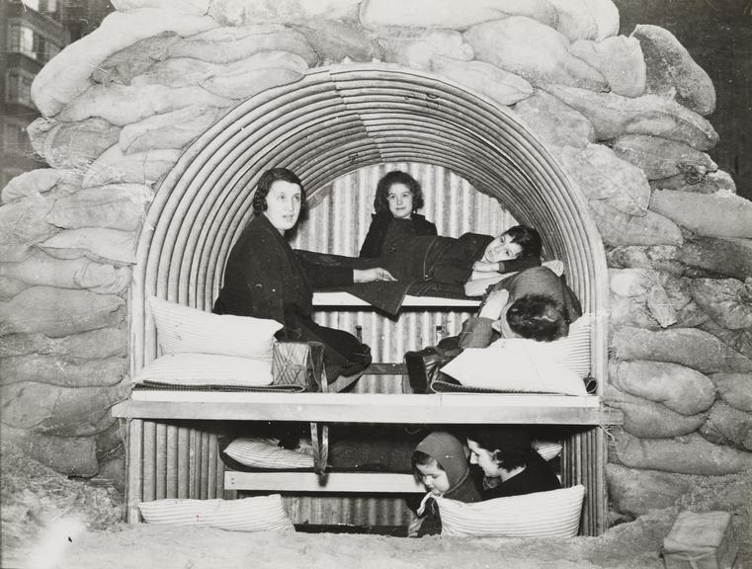
The Anderson Shelter

