Mild
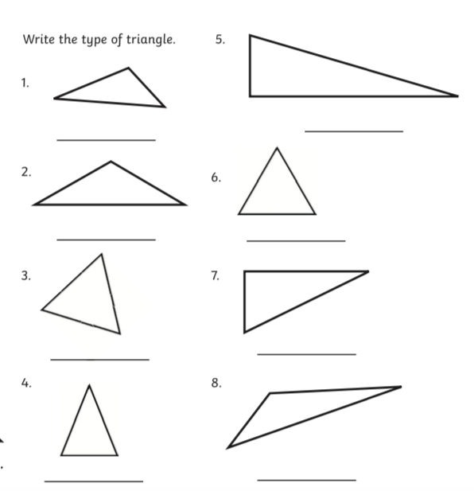
All things Triangles
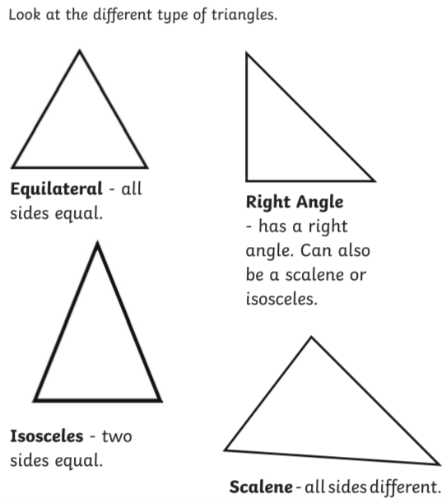

Work out the missing angles. Remember all angles in a triangle add up to 180$°$
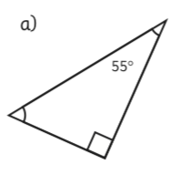

90$°$
90$°$
90$°$

Medium
All things Triangles
3.
_______
_______
_______
_______

4.

Work out the missing angles.
Work out the missing angles.

g)
f)

Remember right angles are 90 degrees 90$°$

k)
l)
j)

Spicy
All things Triangles
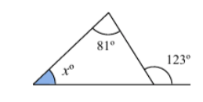
4.
3.
j)
i)
h)
g)
f)
k)
o)
n)
m)
l)
Work out the size of angle $x$ in each of the following triangles.

-

