The Easter Shop Gp(1)
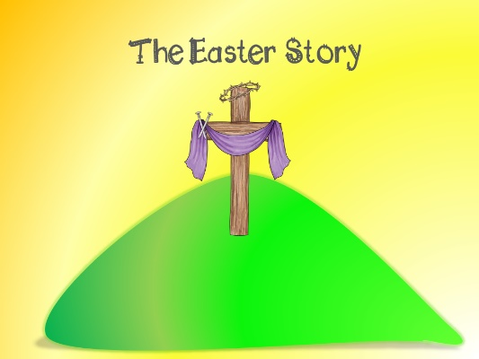


You are going to buy Easter gifts for a family of four
Mum, Dad and two children aged 11 and 7

You have a BUDGET of £100
You may spend up to £100, but you must not spend more than £100

You and your partner will choose gifts from
The EASTER SHOP

You must show which GIFTS you have chosen for each member of the family
and how much they COST

You must show us the TOTAL COST
for each person

You must show us the GRAND TOTAL
for the whole family

