Rationing in World War Two

What was the main reason for food being rationed during the war?
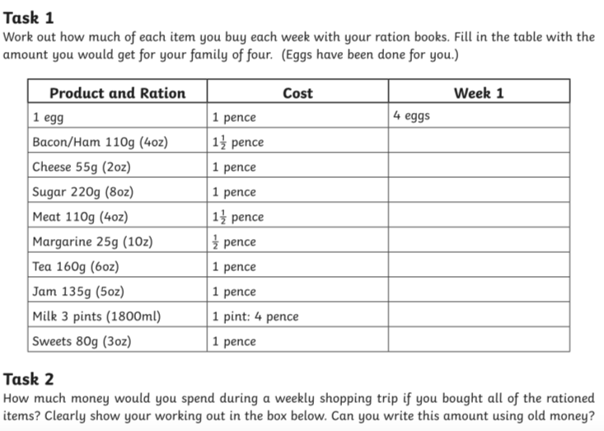
______________________________________________________________________________________________________________________
If there are 12 pence in a shilling, what would your answer be in shillings and pence?
Work out your answer in pence first of all.

