Maths Investigation
‘All The Way Round’
What you need:
- a variety of circular objects
- a length of string
- a 30cm ruler
- scissors
- calculator
Diameter
Using your calculator

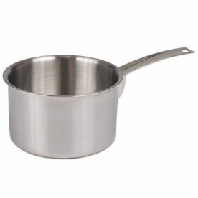

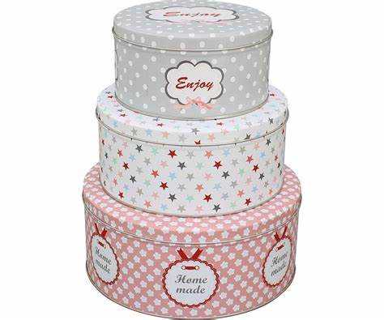

What do you notice about your answers when you divide the circumference by the diameter? __________________________
__________________________________
__________________________________
Are all your answers roughly the same?
__________________________________
What is that answer? ________________

Now turn to your other objects. Measure their diameter and circumference. Record their lengths on the table. Divide the circumference by the diameter and record that answer.
Choose one of your objects. Using your ruler, measure its diameter to the nearest whole centimetre and record your answer on the table (on page 2).
Use a length of string to find the circumference of your object. Mark where the two parts of the string meet and measure the length with your ruler. Record your answer on the table (on page 2).
Using your calculator, divide the circumference by the diameter and record your answer to one or two decimal places on the same table.
For example- circumference is 16cm, diameter is 5cm. 16 ÷ 5 = 3.2

The circumference of a circle is the distance all the way round- just like perimeter.
The diameter of a circle is the distance from one side of the circle to the other through the centre.
(Look at the picture above)
Circumference

Answer Sheet
Name of Object | Diameter | Circumference | Circumference  divided by  diameter
Face cream jar | 5cm | 16cm | 16 ÷ 5 =  3.2
Conclusion

You should find that when you divide the circumference by the diameter the answer is just over 3.
Mathematicians call this number ‘pi’ from the Greek alphabet. The symbol below represents this number.
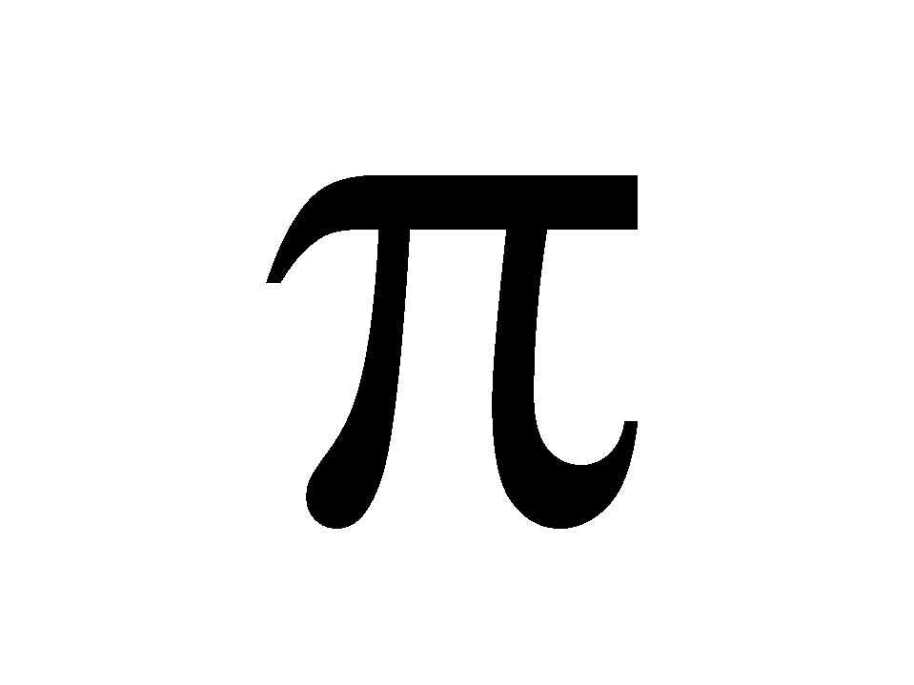

Pi is actually 3.142. So, the circumference of any circle is 3.142 times its diameter.

