
Dice Workout
This Photo by Unknown Author is licensed under CC BY-NC
This Photo by Unknown Author is licensed under CC BY-NC

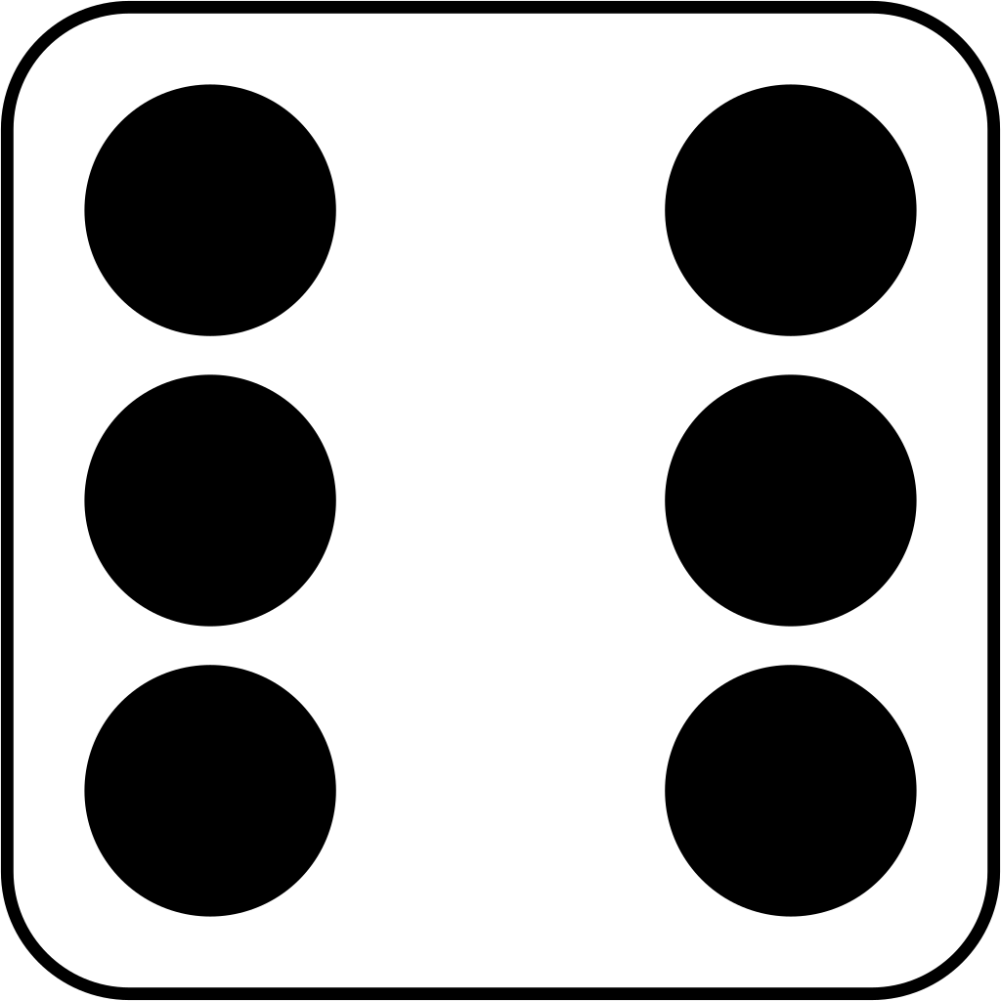
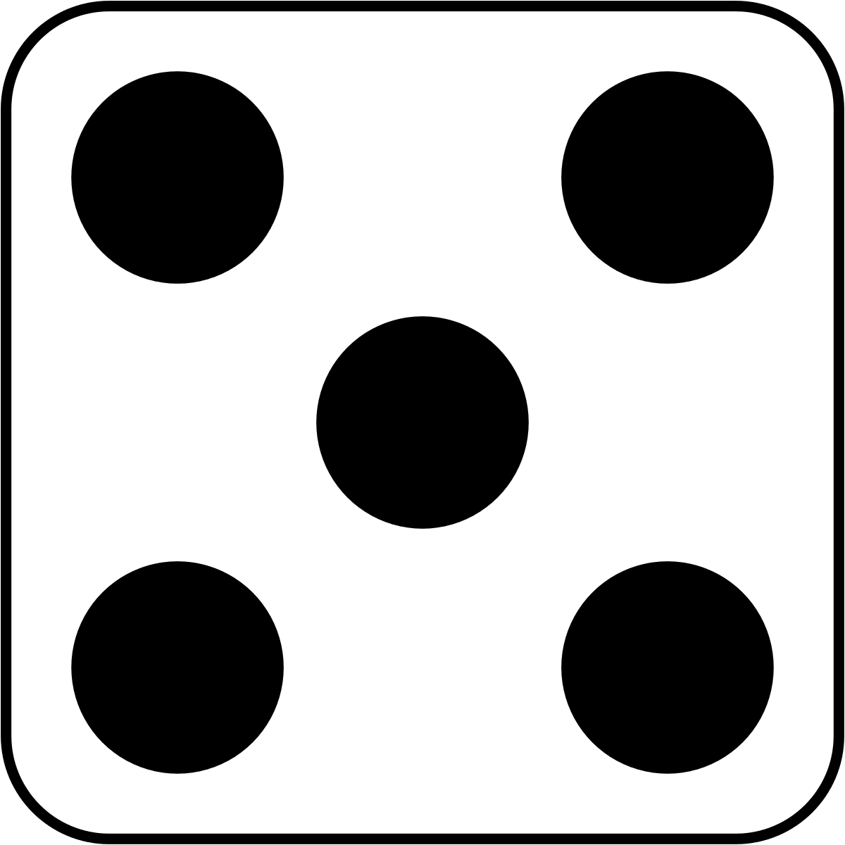
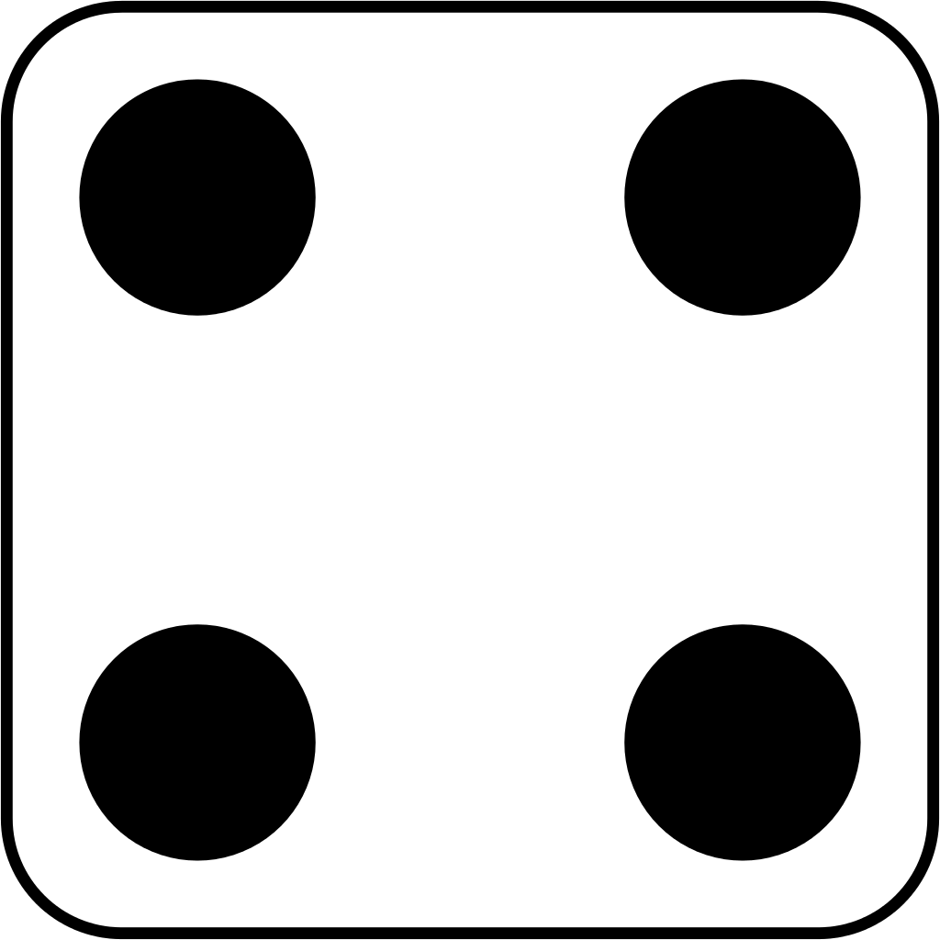
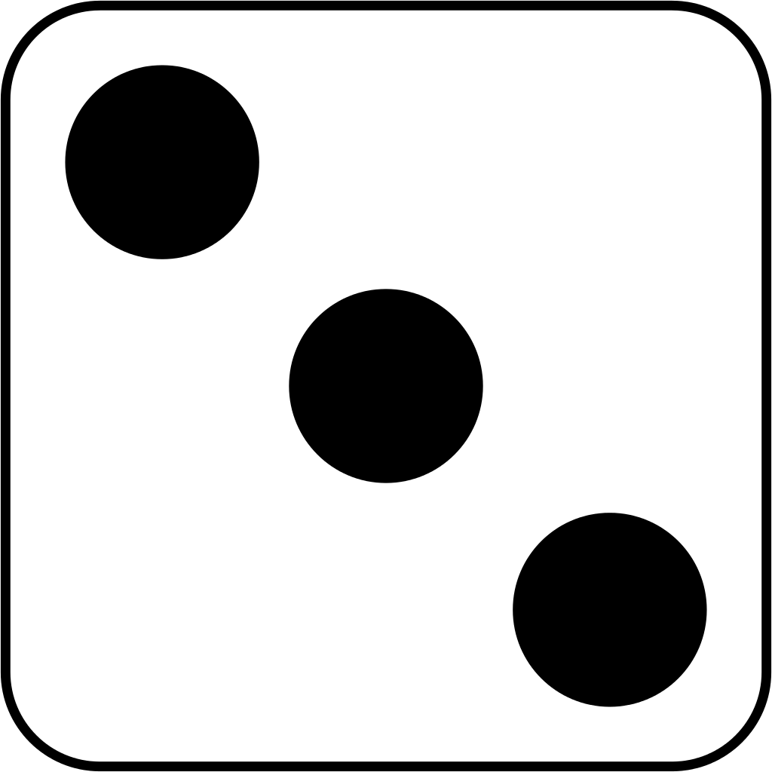
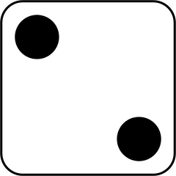

High knees for 10 seconds
Do 10 laps of your garden or living room
Do 5 push ups
Hop for 20 counts
Do 10 star jumps
This Photo by Unknown Author is licensed under CC BY-SA
Balance on one leg for 5 seconds

