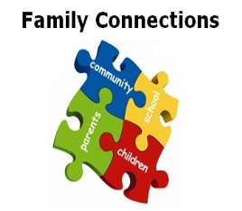
Family Connections
School Age Newsletter 11th May 2020

How is everyone coping with the schooling at home? Can be tough, can’t it?

We have had several referrals in for some help with behavior and routines. If you would like to talk through creating something that works for you at home, please get in touch.
Alex 07500968561 or aimee.nocher@barnardos.org.uk

Respond…
Remember in times of change and uncertainty kids need adults to reassure & support their self-esteem. They need you to praise their efforts and recognise how hard they are trying…
Spend time together using jigsaws/scissors – give positive praise for their efforts/ trying/ time spent and model persistence until you complete the activity; use lots of encouragement; name your own/child’s emotions
** Remember - older children need to practice sorting things out for themselves, so wait-and-see can be a good first response

Play…
Remember children learn through play. Why not try….

Ready, steady LEGO!
Set a Lego challenge where you can see who
can build a rocket/car/castle the fastest.
With older children draw out designs then fold them up and take it in turns to pick out an idea that you can build – just enjoy being together



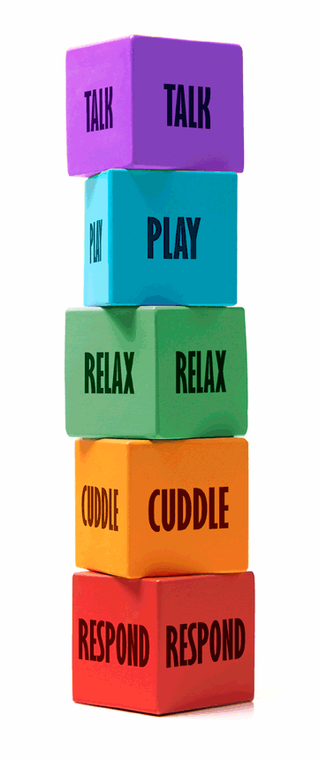
Copyright @ Kate Cairns Associates

Relax…
Some ideas to reduce child stress levels are…

Have a Spa Day
Take care of yourself and each other
Use washing up bowls for a foot soak before you give each other pedicures
Make scrubs and facemasks from ingredients you can find in the kitchen such as olive oil, sugar and honey
Dig out some of the hand/foot creams you might have got for Christmas and practice breathing slowly and deeply to relax as you massage in the cream



Talk…
Some ideas include…

Make a book together. Depending on their age this could be a picture book cut out from magazines and newspapers or ask older children to make up their own story and illustrate it themselves before sharing it with the rest of the family.
.

Cuddle…
Connection in these times is extra
important even for little ones.
We have lots of time so why not…

If the sky is clear, wrap up warm at night with some cosy blankets and cuddle up on your doorstep or garden for some stargazing.
For younger children you could watch
The sunset or listen to the birds singing.
The Sky at Night website or Starmap
App have some tips on what you can
look out for!

