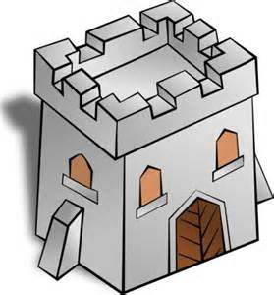
Building Towers
You need a pile of cubes in two colours
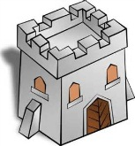

How many different towers can you make?

The towers must be 2 cubes high and they must all be different.

Colour these pictures to show your towers.

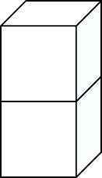

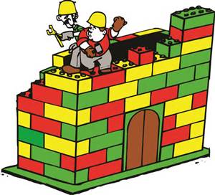
Going Further

Now build towers 3 cubes high.

How many can you build? Are they all different?
FS
Finding All Possibilities

