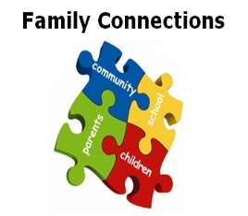
Family Connections
Parent Newsletter & Tips on Wellbeing 11th May 2020

Connect…
Good relationships can still be maintained during self-distancing. Why not try to …
- Set up a time and play a family board game. Or have a go at making up
your own game.

Take Notice…
As the world around us slows down, pause and notice the changes. Why not try…

- Take the time to notice nature.
Notice the birds in the garden or
have a go at making some bird
feeders to attract them in.


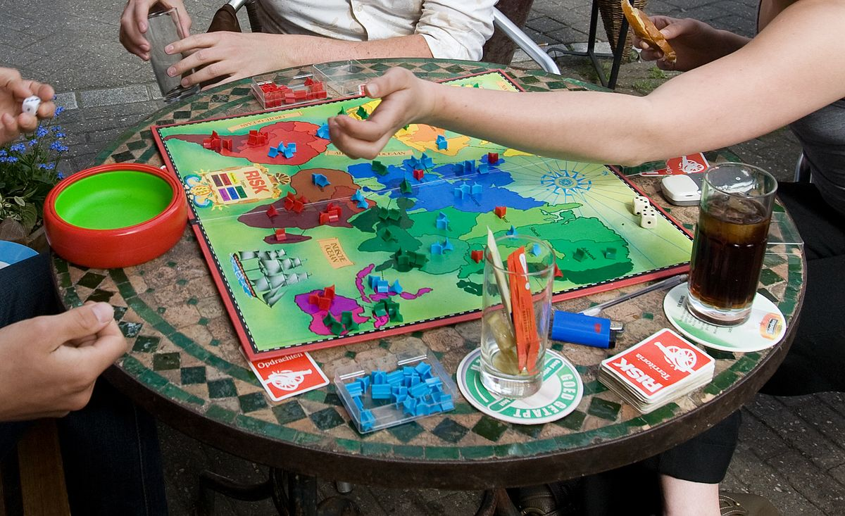

Keep learning…
Learning is important to keep your brain active and maintain or improve well-being.
Suggestion…

- Start a new learning course. The Open University
has made a selection of courses free during the
current situation.

#WECAN learn and have fun….
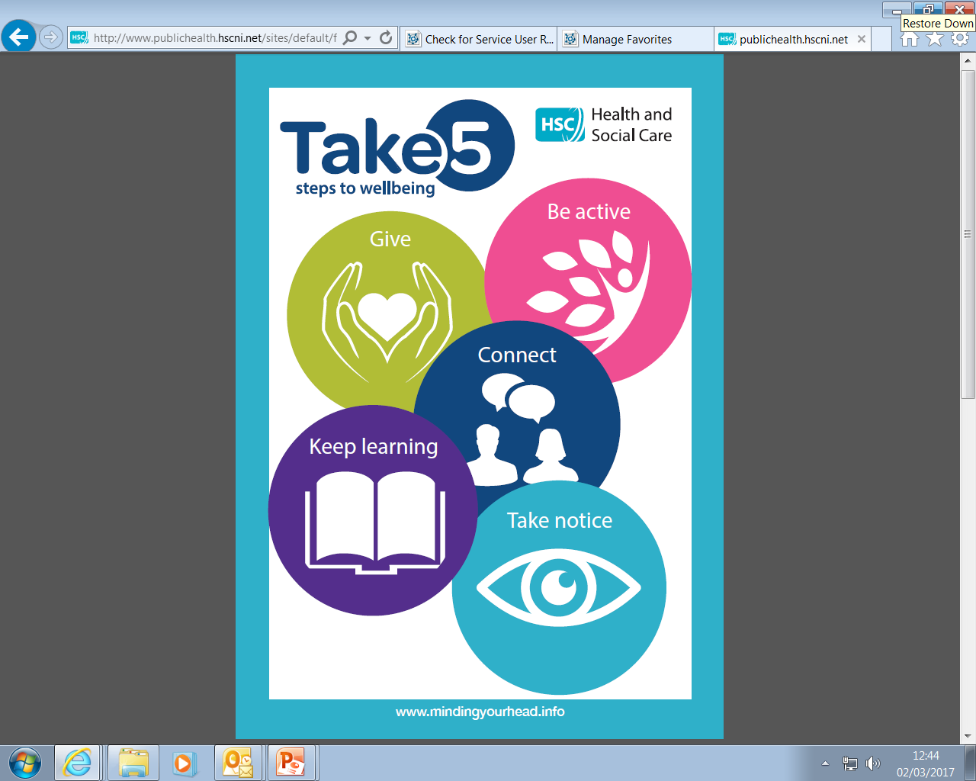



Give…
Giving to others can stimulate the reward areas in the brain, creating positive feelings. Suggestion…

- Post some of your children’s
drawings to a local nursing
home to brighten up their
walls.

Be Active…
Being active can improve our mental wellbeing and improve sleep …
- Try some simple stretches or
some armchair exercises.
Tins of beans make good
weights!
.


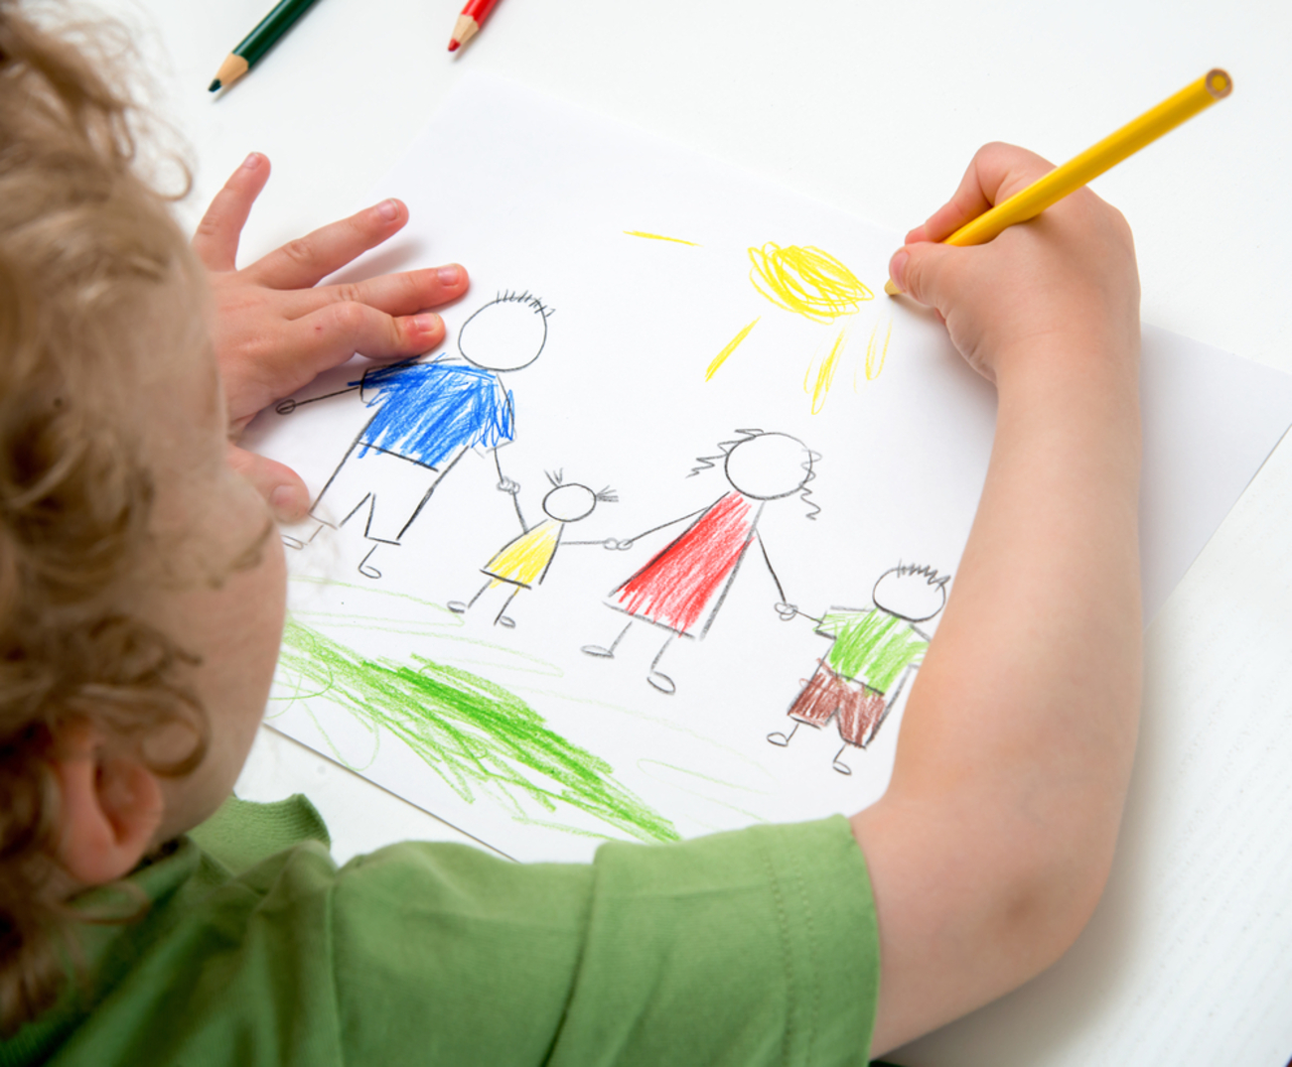
We hope you enjoy our weekly newsletter bringing you simple ideas you can do at home during social issolation …
Follow us on Family Connections Top Tips page on FB too.

