
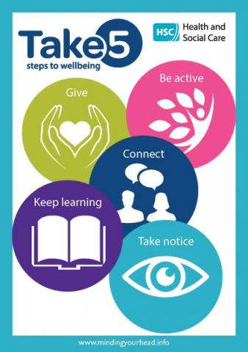

Spring 2020
Dear Parents and Guardians,
Never before has our mental health and well-being, as well as that of our children been more important.
You may be finding the children are experiencing some days that are better than others when it comes to engaging in home-learning, managing their emotions and being removed from their wider family and friends.
The most important thing for all of us right now, is to feel as safe and as happy as we can, so please know that whilst our dedicated teachers are providing home-learning opportunities for every child at home during this time, we do not expect every child to get through every task suggested or available each week.
We are realistic to the demands on your time at home, and the fact that working at home is not, and cannot be like working in school, surrounded by peers.
All any of us can do, is the best we can, when we can, and we should feel very proud of ourselves for that!
These are unprecedented, strange and anxious times for us all.
Home-learning is there as a guide for you to follow at, and there to be enjoyed by the children, at times that work for your family. Please don’t worry if you haven’t quite achieved everything you hoped to that day, or that week!
The key skills we would suggest you make your focus, are those of reading and mental maths.
By using Bug Club to access books that your child’s teacher has allocated, at a level that it right for your child, the children can answer questions as they go, and show their understanding of the texts read.
The maths games available on Education City and Top Marks are also great, and a fun way to practice those essential maths skills that set and secure the foundations for your child when understanding and handling numbers.
Keeping a diary can be a great way of practising writing skills, whilst exploring how your child feels during these strange times. By daily activities and feelings down, this will help the children to explore their emotions and to know that everything they are feeling is normal, and valid.
Using the social story attached can help explain this new way of working and living to your child, at a time where it must seem very confusing to them. See the links regarding Julia Donaldson’s stories that have been adapted for children to explain the changes in their lives right now too.
There is no doubt that this is an emotional time for young people, as it can be for us as adults too, and they may be feeling over-whelmed by the changes they are experiencing in their lives. The inability to see family and friends will be hard on them especially.
If we look at the 5 Steps to Well-being, as published by the Health and Social Care Trust, they are as relevant today, if not more so, than they were before social distancing and isolating ourselves became an essential way of life. They are:
Connect – stay in touch
Be Active - indoor and outdoor activities
Take Notice – appreciate the small things
Keep Learning – challenge yourself
Give – Do something nice for others

With a different approach, we can still follow these steps and help support our emotional well-being, as well as that of the children in our lives.
Some suggestions on activities the children could do when staying at home:
Connect: Writing letters or sending drawings to relatives they cannot see, would be a great way for the children to stay in touch with their family, whilst doing something nice for others too!
Paint or draw a rainbow and place this in your window, as a sign of support and togetherness
Paint a stone with a rainbow, and leave it on a neighbour’s doorstep.
Be Active: Taking up our opportunity for one outdoor form of exercise a day – a walk, a scoot or a cycle. Outdoor play – kicking a ball, bat and ball, skipping if you have access to a garden, as well as indoor YouTube activities such as PE with Joe Wicks; Dancing with Oti Mabusi or Cosmic Kids Yoga, which is excellent, and helps promote mindfulness and relaxation in our children.
Take Notice: Close your eyes and listen to the different sounds you can hear within your home as well as the sounds outside, feed the birds, meditate, focus on deep breathing exercises
https://www.mindful.org/meditation/mindfulness-getting-started/ Meditations
https://youtu.be/8NB3ihqPQGw Meditation for Primary School Children
Keep Learning – your home learning page is full of suggested activities to keep you busy and up to speed on skills and facts learnt this year. Around the home there will be other learning opportunities, such as helping out with housework and cooking!
Give: We can give our time, as well physical things, to others… give someone a phone call or make something for a family member or friend – a card, a rainbow, a cake, a painted stone…
On Thursday at 8pm, we join people around the country, by standing at an open window, or our front door, to give a HUGE clap to everyone who works within the NHS, as well as other front-line services, to show just how grateful we all are for their courage, care and kindness, now more than ever!
Please also remember that we have strong links with Barnardos, and should you want to chat to someone, or seek advice, please know that you can still contact Aimee from Barnardos by telephone or email. Here contact details are:
Aimee Nocher
Tel: 07500 968 561
Email: aimee.nocher@barnardos.org.uk

Please know that we are here for you too. We are in this together, and if there is anything we can do to help you, or help point you in the right direction for help or advice if needed, please email us, and know how much we care about each and every one of our families, especially during a time as challenging as this.

Should you want to get in touch, my email is fsmart676@c2kni.net, or Mr Armstrong can be reached on his email: jarmstrong775@c2kni.net.

With Warmest Wishes,

Fiona Smart.

