Tuesday 26th May WALT use adjectives.

Farm animal adjectives
Look at the pictures of the farm animals below. Can you think of an adjective to describe them?

Farm Animal | Adjective
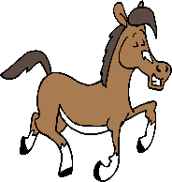 | ____________________ horse
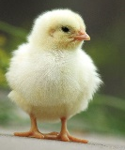 | ____________________ chick
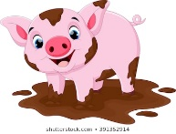 | ____________________ pig
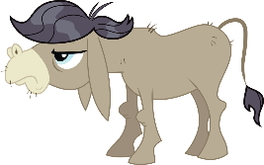 | ____________________ donkey
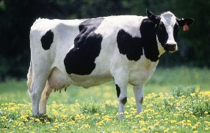 | ____________________ cow
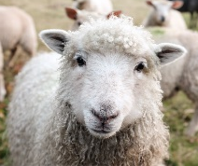 | ____________________ sheep
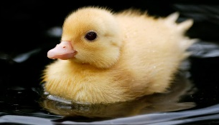 | ____________________ duckling
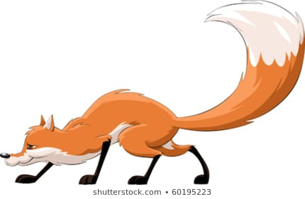 | ____________________ fox

