Thursday 28th May WALT write sentences about the farm.
Farmyard Fun
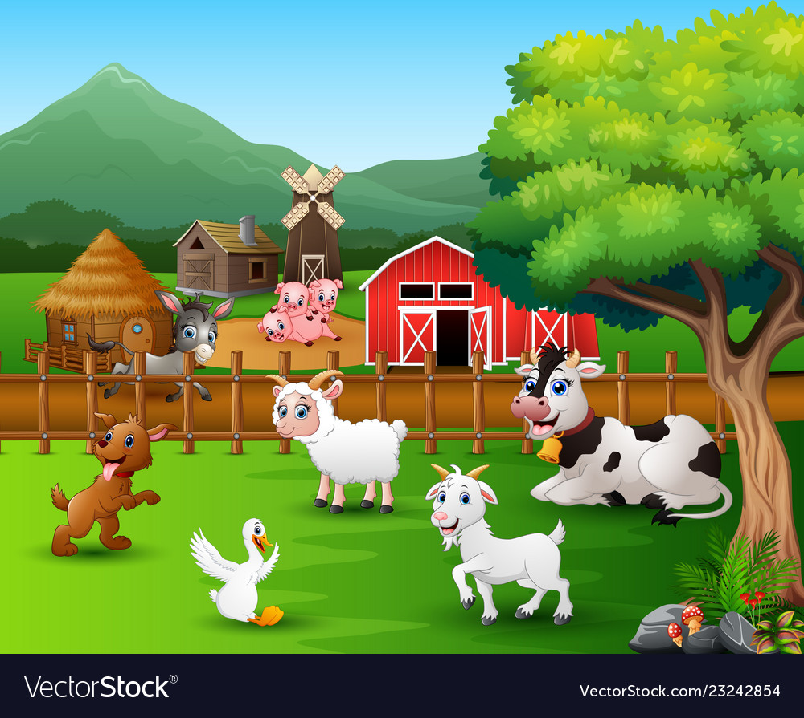
Look at the picture below. Describe what you can see at Farmer Brown’s farm.

__________________________________________________

__________________________________________________
__________________________________________________
__________________________________________________
__________________________________________________
__________________________________________________
__________________________________________________
__________________________________________________

