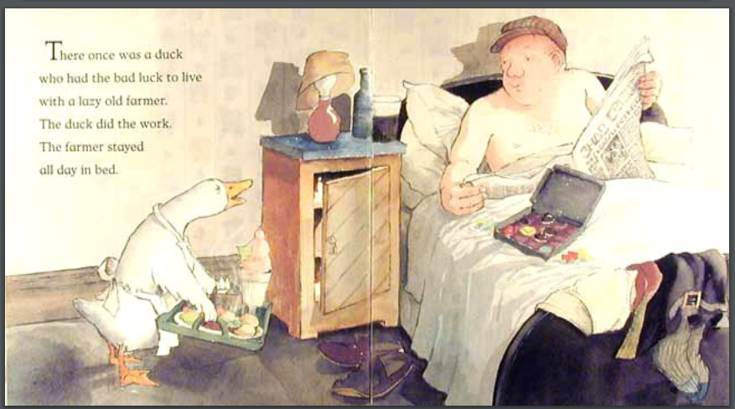
Farmer Duck
Look at the picture. How do you think Farmer Duck felt? How can you tell?
How would you help Farmer Duck feel better?

